**IBM ASSIGNMENT- I**

**TEAM ID :** **:PNT2022TMID26639**

**NAME : EDISON K**

**ROLL NO : 212919106022**

Create a circuit with Piezo alarm, PIR Sensor, TMP Sensor with below functionalities:

1.Alarm should sound in one manner if temp is above 60C

2.Alarm should sound with another frequency if motion is detected in PIR Sensor.

**CIRCUIT LAYOUT:**

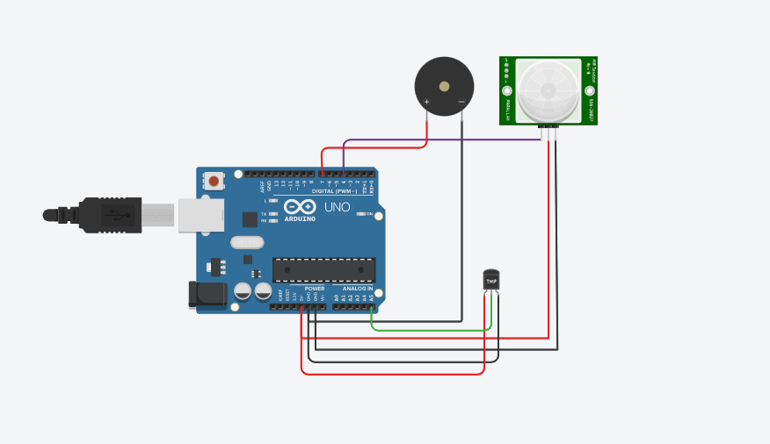

**CODE:**

// C++ code

//

void setup()

{

Serial.begin (9600);

pinMode(4, INPUT);

pinMode(7,OUTPUT);

pinMode(A5,INPUT);

}

void loop()

{

int motion = digitalRead(4);

if (motion==1){

Serial.println("Motion detected");

tone (7,200);

delay(350);

}

else{

Serial.println("No Motion");

noTone(7);

}

{

double data=analogRead(A5);

double n=data/1024;

double volt=n*5;

double off=volt-0.5;

double temperature=off*100;

if (temperature>59.99){

Serial.print("Temperature data:");

Serial.println(temperature);

tone(7,1000);

delay(350);

}

else

Serial.print("Temperature data: ");

Serial.println(temperature);

noTone(7);

}

}

**OUTPUT:**

**PASSIVE INFRARED SENSOR:**

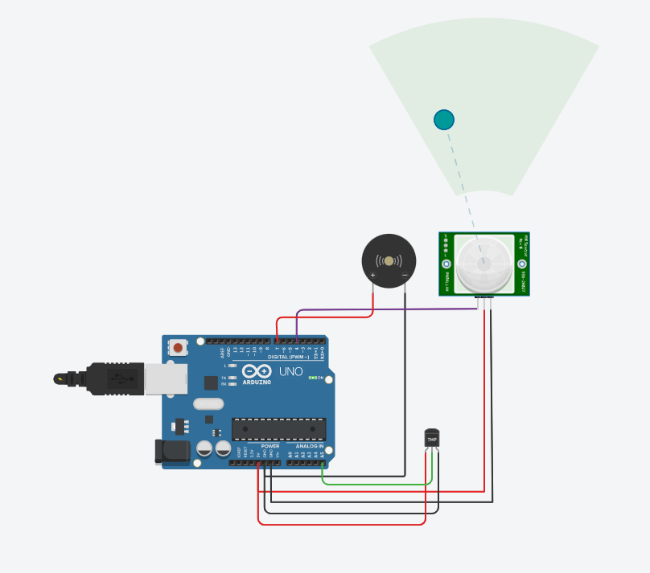

**TEMPERTURE SENSOR (AT 60°C):**

